Experiment 2.2
Verification of Even and Odd Signal Decomposition
Aim
Decompose a signal into even and odd parts and verify reconstruction.
Apparatus Required
PC with MATLAB.
Program (MATLAB)
% Verification of Even and Odd Signal Decomposition
clc;
clear;
close all;
% Time axis
t = -5:0.1:5;
% Original Signal
x = t.^3 + t;
% Time-reversed Signal
x_rev = (-t).^3 + (-t);
% Even Component
xe = (x + x_rev)/2;
% Odd Component
xo = (x - x_rev)/2;
% Reconstruction of Original Signal
x_reconstructed = xe + xo;
% Plotting
figure;
subplot(4,1,1);
plot(t,x,'LineWidth',2);
grid on;
title('Original Signal x(t)');
xlabel('Time');
ylabel('Amplitude');
subplot(4,1,2);
plot(t,xe,'LineWidth',2);
grid on;
title('Even Component x_e(t)');
xlabel('Time');
ylabel('Amplitude');
subplot(4,1,3);
plot(t,xo,'LineWidth',2);
grid on;
title('Odd Component x_o(t)');
xlabel('Time');
ylabel('Amplitude');
subplot(4,1,4);
plot(t,x_reconstructed,'LineWidth',2);
grid on;
title('Reconstructed Signal x_e(t) + x_o(t)');
xlabel('Time');
ylabel('Amplitude');
Output Generated Graph
Original signal plus even (dashed) and odd (dotted) components.
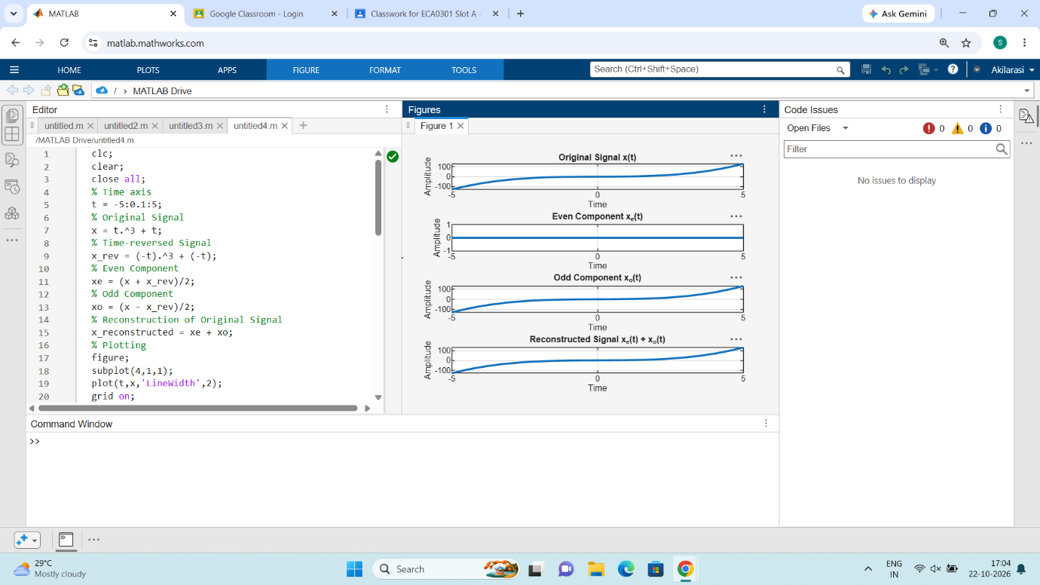

Result
Signal equals sum of even and odd parts.

